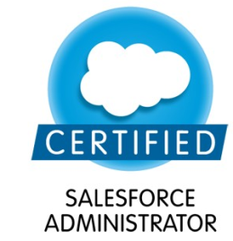
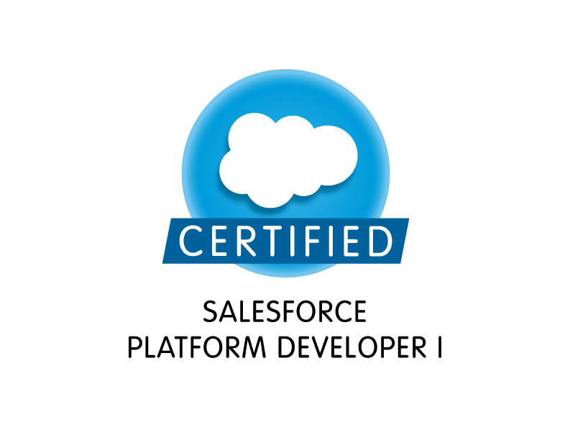

Venkata Naga Deenamsetty
402-819- 9799
deenamsettysanjana@gmail.com

Professional Summary:
- 7 years of IT experience in application design, customization, development, support on SalesForce.com Platform, Web based application using Java/J2EE Technologies.
- Proficient in all phases of SFDC like requirements gathering, analysis, design, development, testing and deployment.
- Salesforce.com Certified Administrator [ADM-201]
- Administration, configuration, implementation and support with salesforce technologies.
- Expertize in designing and implementing SFDC configuration changes, including creating custom objects and fields, validation rules, workflows, approval processes, email alerts, templates, etc.
- Hand on experience with Force.com, Apex, Visualforce, Web services and Metadata API.
- Worked with importing and exporting data from excel sheets into Leads, Accounts, Opportunities, etc using Data Loader and Import Wizard.
- Knowledge of Service Oriented Architecture and CRM business processes like Forecasting, Campaign and Lead Management, etc.
- Experience with InfusionSoft setup and management with a software startup.
- Experience with Informatica, QTP and Rational rose testing in both corporates and startups.
- Execution of Alpha/ Beta testing and User testing and System test plans.
- Working knowledge of Report generation and analysis of data in Salesforce.
- Practical experience with Java development and testing using Eclipse IDE.
- Real time experience with website development and management using HTML, CSS, MySQL including database management and query execution.
- Experience in working with Agile and SCRUM development methodologies.
- Virtualization experience with VMware workstation, VSphere, ESXi 5, Virtual Box, etc. with Windows Server 8/12 deployment and management.
- Experience with DHCP, DNS, FTP, Tunneling, Cisco Routers, Firewall management in corporates.
- Think critically, learn quickly, develop expertise and produce immediate contributions. Blend Knowledge, creative and analytical abilities to produce bottom-line results.

Certifications:
- Salesforce.com Certified Developer

TECHNICAL SKILLS

CRM Applications | Salesforce.com, Siebel 8.1.1.5, 8.1, 7.8, 7.7 (versions)
Sales force Tools | Change Sets, Eclipse, Force.com Eclipse IDE Plug-in, Force.com Explorer, Force.com Data Loader, Force.com Excel Connector, Force.com Platform (Sandbox, and Production) and Sand box testing.
Frameworks and Architectures | Model View Controller (MVC) based solution design
Project Management Tools | MS-PROJECT 2000 , MS Visio, MS Word, MS Excel, MS PowerPoint, HP Quality Center
Languages | Java, J2EE, C# and .Net
Databases Force.com | DB My SQL, Oracle 9i/10g
Salesforce Technologies | Salesforce CRM, Salesforce SFA, Apex Language, Apex Classes/Controllers, Apex Triggers, SOQL, SOSL, Visual force Pages / Components, S-Controls, Apex Web Services, AJAX, Workflow & Approvals, Dashboards, Analytic Snapshots, Custom Objects
SDLC Methodologies | Waterfall, Agile Methodology
Tools for Version Control | Clear case, MS-VSS
Enterprise Application Integration Software (EAI) | Understanding of SOA (Service Oriented Architecture) & Experienced in using SAP XI for defining data maps.
Web Technologies | SOAP, REST, WSDL, HTML, AJAX, JavaScript, XML, CSS, JSP.
ETL/Integration Tools | Force.com, Data loader, Force.com Workbench.

Professional Experience

Client: Wells Fargo Jan2016-Present
Charlotte, NC.

Role: Salesforce Developer
Wells Fargo uses multiple Salesforce instances for various in-house applications. Mainly focus on to expand Salesforce Chatter functionalities with custom APEX code applications, third-party tools, and multiple AppExchange apps.

Responsibilities:
- Gathering business requirements, designing appropriate solutions, and implementing solutions in Force.com platform, especially in enhancing Salesforce Chatter in highly dynamic agile environment.
- Worked on analyzing the complete Apex classes, Apex Triggers and Pages in the Salesforce.com at the design phase, which also included documenting the use and effect of these in the current instance for the migration/implementation phase
- Have played a major role in developing and supporting all the Integrations done in the Salesforce.com instance for the client.
- Performed regression tests on the existing code using Eclipse and made the necessary changes to enhance the code wherever necessary.
- Interacted with testing and the development teams for the development and testing of the code.
- Created many Email Templates and Mail Merge Templates and was involved in doing the mail merge for different standard and custom objects.
- Have worked on moving data from external legacy system into Salesforce application using Apex Data loader & CSV files.
- Involved in setting up field level access for each custom object created based on the user's role within the organization
- Involved in Unit Testing, for the customizations and developments done during the project.
- Worked on work-flow business rules by using workflows, process builders, and visual flows.
- Created page layouts, search layouts to organize fields, custom links, related lists and other components on a record detail and edit pages. Developed and configured various custom reports and report folders for different user profiles.
- Developed and implemented both the time dependent and time independent workflows as per the requirement. Developed and deployed Workflows and approval process wherever necessary. Created profiles, roles and implemented object level, field level and record level security.
- Performed the role of support engineer for the internal users and helped them in getting used to the application, generated reports and saved them for further access to the users. Involved with Salesforce.com Premier Support and handled the support cases with the help salesforce.com support.
- Designed, implemented and developed the Custom Objects, Page Layouts, Custom Tabs, and Components to suit to the needs of the application.
- Implemented enhancements on objects like Accounts, Leads, Contacts, Opportunities, Quotes, Activities, Tasks, Reports and Dashboards.
- Scheduled retrieval of report data with analytic snapshots to dump the data on daily basis.
- Used sandbox for testing and deployed the code into the production environment.
- Created an interactive User Interface to improve customer experience while recording the damage incurred to the property using Visualforce pages.
- Customized dashboards to track the usage for productivity and performance of business centers.
- Deployed and Configured Chatter Usage Dashboards to keep track and generate reports and dashboards for high ranked users inside organization.

Client- QUALCOMM, NY July 2015-Dec 2015
Salesforce Admin-Developer

- Involved in SFDC application setup activities and customized apps to match the functional needs of the organization.
- Created Roles, Profiles, Access Settings, Workflow Rules, Validations, creation and modification of fields and page layouts, upload of data and worked extensively on Accounts, Contacts, Leads, Opportunities, Activities, other Standard Objects and Customized Objects for additional fields, Layouts, record types and validation rules.
- Developed Apex Classes, Visualforce pages and Apex Triggers to develop the custom functionality as per the requirements.
- Responsible for setting up login restrictions and resetting the user passwords, Implemented public access settings for sites, restricted login hours, and restricted login IP ranges on profiles.
- Involved in creating, monitoring, and measuring campaigns with Salesforce CRM Marketing. Created Workflows and Approval processes and developed validation rules.
- Involved in minor corrections and enhancements to SFDC application required by business users from time to time.
- Developed VisualForce pages to manage sales within Salesforce.
- Worked with teams to develop Apex classes, controllers and tested them before deployment.
- Design and implemented Custom Objects, Page Layouts, Custom tabs, Components and S Control to suit the needs of the application.
- Created multiple profiles and configured the permissions based on the organizational hierarchy requirements.
- Customized tabs for various business groups and business centers.
- Assisted staff in developing reports and familiarizing with the system.
- Extensive use of Data Loader for insertion, updates and bulk import of Accounts, Leads, Contacts and Opportunities.
- Defined lookup and master-detail relationships on objects and created junction objects to establish many-to-many relationship amongst objects.

JPAL Global- Hostelly, NY Sept 2014-Jun 2015
Salesforce Admin-Developer
- Developed and deployed PMS software (Hostelly) for our hostels and rental properties.
- Created user Roles and Profiles, security controls and shared settings.
- Provided the training to the internal business users to use the application and develop their own custom reports.
- Customized the Dashboards to the track usage for productivity and performance of business centers and their sales teams.
- Interacted with Business operations, understand business model, involved in gathering requirements, communicated business process, translated needs into Salesforce terms, developed data model, defined objects and relations.
- Functional and user testing of Hostelly after deployment at various sites.
- Hands on support for the software users.
- Trained 10+ people to work with the new software in multiple locations.
- Worked to setup sales and marketing backend using InfusionSoft and Salesforce.
- Setup campaigns and opportunities for the sales and marketing team.
- Customized and setup Dashboards to track usage for productivity and performance of properties and the on-site teams.
- Used Data Loader to export data from one sandbox and import it to another.
- Created labels and custom settings and accesses them using Apex classes.
- Setup Visualforce pages to capture various customer enquiries and implemented logic for migration of cases to different queues depending on the enquiry
- Developed validation rules, workflow rules and auto response rules and related them to tasks, email alerts and field updates.
- Designed letterheads and email formats using various integrations with Zapier.
- Communicated with customers and responded to customer complaints and suggestions and made appropriate enhancements.

Client- Stripe, USA Jan 2014 - July 2014
Salesforce Admin-Developer
Involved with setting up and integration of Salesforce and Stripe.
- Worked closely with sales and business team and performed analysis of requirements.
- Performed complete analysis of existing systems in organization and corresponding business process for sales and marketing.
- Developing Visual Pages to include custom functionality and implemented Apex Classes to provide functionality to the visual pages.
- Worked on mobile compatibility with salesforce1.
- Customized layouts to present only relevant information to users by reorganizing fields, related lists, and other components on the UI.
- Designed solutions by customizing various objects in SFDC.
- Developed Apex class and triggers, Test and Control Classes for functional needs.
- Responsible for configuring Data Loader for customer records, uploading data in CSV files
- Designed and deployed Custom tabs, Validation rules, Approval processes and Auto-response rules.
- Created Report and Dashboards to keep track of the customers and transactions as per Management requirements and visibility.
- Setup Email templates and Visual force pages for responses to customers.

DRDO- DLRL, India Jan2012 - Sept 2013
Software and Salesforce developer,

- Designed and developed a software messenger application for inter-departmental communication over their private LAN.
- Interpreted the UI and system needs and used Java, Photoshop to deploy the messenger.
- After deploying the messenger, got updates with user testing to check for improvements.
- Developed additional code to setup file sharing over secure channel in addition to regular chat functionality
- Developed APEX class, Controller class and APEX Triggers from various functional needs in the application.
- Customized several Workflows, validation rules, Triggers, Apex class.
- Deploy SFDC package from one organization to other organization
- Involved in Salesforce.com application setup activities and customized the apps to match the functional needs of the organization.
- Used asynchronous Metadata API to manage setup and customization information
- Worked as part of the research team with other scientists on remote software control software development and testing.

Darien Software Pvt Ltd, India Jan 2011- Dec 2012
Web Developer,
- Developed a data mining tool with emphasis on school curriculum and teachings to improve student grade.
- Procurement and research of data from schools and colleges.
- Used Java, MySQL, Informatica with the project.
- Did testing on the beta version.
- Deployed it in a high school and worked with the staff there on the setup and maintenance.
- Learnt in depth about how to apply theoretical DBMS and Data Mining knowledge in practical way to help with education

BHEL, India, Oct 2009- Dec 2011
Network and System Associate:
- Worked with DHCP, FTP, DNS, Tunneling and setup of networks and systems.
- Configured and implemented basic networking infrastructure
- Worked with setup of Windows Servers and virtualization technologies.
- Trained with the networking manager to get a hands on experience of networks setups.
- Maintenance and support for over 100 systems and their networks.

